HOSPITAL MANAGEMENT SYSTEM

**A PROJECT REPORT**

**Submitted By**

**SAKSHI GOYAL**

**University Roll No- 2200290140132**  **SAURABH GUPTA**

**University Roll No- 2200290140137**

**Submitted in partial fulfillment for the Degree Of**

MASTER OF COMPUTER APPLICATION

**Under the supervision of Professor**

**MR. PRASHANT AGARWAL**



# Submitted to : Department Of Computer Applications

**KIET Group of Institutions , Ghaziabad Uttar Pradesh-201206**

**(Sep 2023)**

**CERTIFICATE**

It is to Certified that **Sakshi Goyal , Saurabh Gupta** has/ have carried out the project work having “**HOSPITAL MANAGEMENT SYSTEM”** (**Mini Project-KCA353**) for **Master of Computer Application** from Dr. A.P.J. Abdul Kalam Technical University (AKTU**)** (formerly UPTU), Lucknow under my supervision. The project report embodies original work, and studies are carried out by the student himself/herself and the contents of the project report do not form the basis for the award of any other degree to the candidate or to anybody else from this or any other University/Institution.

**Date:**

**SAKSHI GOYAL (2200290140132)**

**SAURABH GUPTA (2200290140137)**

…………………

…………………….

This is to certify that the above statement made by the candidate is correct to the best of my knowledge.

Date:

**MR. PRASHANT AGARWAL DR. ARUN TRIPATHI**

**Placement Coordinator Head Of Department**

**Department of Computer Applications Department of Computer Applications**

**KIET Group of Institutions, Ghaziabad KIET Group Institutions, Ghaziabad**

**ABSTRACT**

Our Project Hospital Management System stores the details of patients , doctors and give them their unique id . Our software has the facility to give a unique id for every patient and stores the details of every patient and the staff automatically. User can search availability of a doctor and the details of a patient using the id .The Hospital Management System can be entered using a username and password.

It is accessible either by an administrator or receptionist. only they can add data into the database. The data can be retrieved easily. The interface is very user-friendly. The data are well protected for personal use and makes the data processing very fast .

**ACKNOWLEDGEMENT**

Success in life is never attained single handedly. My deepest gratitude goes to my thesis supervisor, Mr. Prashant Agarwal for his guidance, help and encouragement throughout my research work. Their enlightening ideas, comments, and suggestions.

Words are not enough to express my gratitude to Dr. Arun Kumar Tripathi Sir, Professor and Head, Department of Computer Applications, for his insightful comments and administrative help at various occasions.

Fortunately, I have many understanding friends, who have helped me a lot on many critical

Finally, my sincere thanks go to my family members and all those who have directly and

indirectly provided me moral support and other kind of help. Without their support,

completion of this work would not have been possible in time. They keep my life filled

with enjoyment and happiness.

**SAKSHI GOYAL (2200290140132) SAURABH GUPTA(2200290140137)**

**TABLE OF CONTENTS**

**CERTIFICATE i**

**ABSTRACT ii**

**ACKNOWLEDGEMENT iii**

**CHAPTER : 1 PROJECT AND BACKGROUND**

* Introduction
* Literature overview
* Advantages and Disadvantages
* Objectives and issues
* Scope

**CHAPTER :2 CONCEPT , TECHNIQUES AND SRS**

* Research Methodology
* Conceptual Review
* Feature and research outcome
* System Interfaces
* Data Flow Diagram
* Use Case Diagram

**CHAPTER :3 SPECIFIC REQUIREMENTS**

* Performance Requirements
* Security Requirements
* Software System Attributes
* Functional Requirements
* Non – Functional Requirements

**CHAPTER :4 DESIGN**

* ER Diagram
* Data Design

**CHAPTER :5 FEASIBILITY STUDY**

* Technical Feasibility
* Operational Feasibility
* Economical Feasibility
* Schedule Feasibility

# 

# 

# CHAPTER – 1

# (PROJECT AND BACKGROUND)

* **INTRODUCTION**

A HOSPITAL MANAGEMENT SYSTEM is a computerized management system . This management system

has been developed to form whole management system including Doctors (consultants) , Patients , and

Diagnosis etc. This system also keeps the records of hardware assets besides software of this organization .

The proposed system will keep a track of Doctors , Patients , and generation of report regarding the

present status. This project has 33333 based software that will help in storing , updating and retrieving

the information through various user-friendly menu-driven modules .

With the advent of 21st  century, Health care has become an Industry having tremendous potential .

This century witnessed a giant leap in information technology .Computers are not only used to diagnose

the illness or for doing surgery with one hundred percent accuracy , but also they are used to increase the

efficiency in all fields ranging from fixing the appointment with the Doctor to keeping the record of

the Patient . Software application can provide solution and services for the global health care Industry .

By using the cutting edge technologies , Hospital Management can be improved with efficient work

flow  and communication .  Any  time any  where facilities of  the **INTERNET** have helped the Medical

fields to integrate into a single unit .

Various Hospitals across the globe can be connected together . They can share information and even

services . Details of the Patients , their previous visits etc. are totally not perceptible without a computer .

Relevant information are always stored in the computer and are available instantly in front of the user .

* + **LITERATURE REVIEW**

Due to digital INDIA, we have to connect every-field with the digital India, we have to provide an online platform in field of finding a trainers. It will provide the searching facilities based on various factors such as trainers. Different trainers who provide such facilities can also be the part of web portal. It will provide a better user experience with responsive design, It’s a lot easier and cheaper to make a web based system user friendly across multiple platforms and various screen size. The application is reduced as much as possible to avoid errors while entering the data.It also provides error message while entering invalid data. It also restrict unauthorized access because while trainer is registering they need to provide certificate which later on admin will verify then only trainer can login into this portal. This by this all it provide it is user friendly.

This is basically a Web portal where a user can search Trainers for any hobby very easily. On this portal different trainers who provides these kinds of services will get registered to post their details along with the certificate and user can see the details and can avail the services according to his/ her needs.

* + **ADVANTAGES AND DISADVANTAGES**
* **Advantages**

• The system automates the manual procedure of managing hospital activities.

• Doctors can view their patients’ treatment records and details easily.

• The system is convenient and flexible to be used.

• It saves their time, efforts, money and resources.

* **Disadvantages**

• Requires large database.

• The admin has to manually keep updating the information by entering the details in the system.

• Need Internet connection.

* + **RESULTS AND DISCUSSION**

The IT system has revolutionized the field of medicine. In this fast-paced world of medicine, It is a

daunting task to manage a multi-specialty hospital. A hospital management system (HMS) is a computer or

based system that facilitates managing the functioning of the hospital or any medical set up .

The HMS takes care of all the requirements of the hospitals and can provide easy and effective storage of

information related to patients who come to the hospital for better patient care service. It is a complete hospital

suite serving all functional areas of the hospital. It covers the cycle of hospital workflow from appointment.

* + **OBJECTIVE**

Hospital information systems  provide a common source of information about a patient’s health history ,

and doctors schedule timing . The system has to keep data in a secure place and controls who can reach

the data in certain circumstances.

The main objectives of the best hospital management system are:

* Computerize all the details of the patient and hospital
* Appointment scheduling of patients with doctors for mutual convenience
* To perform automation of workflows
* Secure hospital data and enhance retrievability as it contains sensitive information related to patients, staff, and hospital
* Design a system to improve patient experience
* Reduce operational costs of hospitals
* Provide reports and analytics for management anytime for better decision making
* Connect all departments on a single platform and bring in better coordination across.
* Provide the administration with a single point to retrieve any data
* Handle activities of all departments in a hospital like a pro:
* Reception desk
* Front Office/OPD Management
* Patient management (scheduling, registration, and IPD management)
* Patient care management (pathology labs)
* Labs and radiology department
* Billing department
* Pharmacy/ Medical stores
* Financial Accounting (billing, accounts payable/receivable, payroll, and general ledger)
* Insurance processing
* Inventory management
* Facility management
* Payroll
* **SCOPE**

The scope of a hospital management system (HMS) is extensive, covering various aspects of

hospital operations. An HMS typically includes functionalities like patient registration,

appointment scheduling, electronic medical records (EMR), billing, inventory management,

pharmacy management, and laboratory management. It may also incorporate features for

medical imaging, telemedicine, reporting and analytics, and integration with external systems

like insurance providers and laboratories.

The scope of an HMS is to automate and streamline administrative and clinical processes, improve

patient care coordination, enhance data security and accuracy, optimize resource utilization, and prov

ide valuable insights for decision-making. The scope of an HMS can be customized based on the spec

ific needs and requirements of the hospital implementing it.

**CHAPTER – 2**

**(CONTENT , TECHNIQUE AND)**

**(SOFTWARE REQUIREMENT SPECIFICATIONS)**

* **RESEARCH METHODOLOGY**

The hospital management system will be created in two stages: first, a database will be created; next,

the interface will be customized; finally, the interface will be programmed, and certain codes will be

written. Learn from current systems and adapt from them for a better result. After thoroughly

researching the current system, the development team were able to determine its benefits and

shortcomings and find ways to address the latter. The five primary modules of the solution system were

released. These include managing appointments, managing pharmacies, managing healthcare programs,

and managing doctors[3]. To find a new system as a solution, the analysis of the current system is put

through a comparing process. The best software will be selected after a review of the current software

options[6]. Making a list of tables and specifying their relationships is the first step in building a local

database[4]. The system was implemented using MERN technology which use JavaScript stack that is

used by many large organizations in these days. To implement an end user attractive interface,

development team used several react packages like material UI , React Bootstrap , tailwind CSS and anti

designs. Backend is developed using node is. While implementing the backend developers focused on

security , authorization, validation, authentication, and performance. To achieve those developers, use several packages like package validator, crypted etc. All the inserted data are stored and managed

by a non-relational database. Data administration team have chosen Mongo DB With a scale-out design,

manage massive amounts of data quickly. Allow for simple field and schema modifications and the

storage of unstructured, semi structured, and structured data. All the inserted data are stored and

managed by a nonrelational database. Administration team have chosen Mongo DB With a scale-out

design, manage massive amounts of data quickly. Allow for simple field and schema modifications and

STORAGE OF UNSTRUCTURED, SEMI-STRUCTURED, AND STRUCTURED data. The database was design

in an efficient manner to manage patient information, doctors’ information, Lab test information,

medical program information and drug information. This information is used by the system user when

it is necessary. This system has ease of usability and making required appointments quickly.

* **FEATURES AND RESEARCH OUTCOMES**
* HMS - IMPROVED QUALITY OF CARE
* HMS - INCREASED EFFICIENCY
* HMS - IMPROVED COMMUNICATION
* HMS - COST-EFFECTIVE SOLUTION
* HMS - ENHANCED SECURITY
* HMS - DATA ANALYTICS
* HMS ENABLES TELEHEALTH/TELEMEDICINE
* COMPLIANCE WITH REGULATIONS

For those who adopt HMS solutions whether they are hospitals or any Healthcare Industry like college , clinic

or institute . This software helps to increase patient satisfaction , improve outcomes and comply with regulations .

HMS provides a platform for Healthcare industries to manage patient records , Hospital Administration , Ancillary

Services , clinical support , Interface , Decision support and Financial accounting .

* **SYSTEM INTERFACES**
* **User Interfaces**
* It also gives a description of the hardware, software and communication interfaces and provides basic prototypes of the user interface.
* **Hardware Interfaces**
* **Laptop/Desktop PC**-Purpose of this is to give information when Patients ask information about doctors, medicine available lab tests etc. To perform such Action it need very efficient computer otherwise due to that reason patients have to wait for a long time to get what they ask for.
* **Wi-Fi router** - Wi-Fi router is used to for internetwork operations inside of a hospital and simply data transmission from pc’s to sever.
* **Software Interfaces**
* Mysql server - Database connectivity and management
* OS Windows - Very user friendly and common OS ▪ JRE 1.8 - JAVA Runtime Environment for run Java Application and System.
* **System Specifications**
* **H/W Requirement**
* Core i3 processor
* 2GB Ram.
* 20GB of hard disk space in terminal machines
* **S/W Requirement** 
  + - * Windows 11 operating system
      * MySql Server
* **DATA FLOW DIAGRAM(DFD)**
* **CONTEXT LEVEL DIAGRAM**

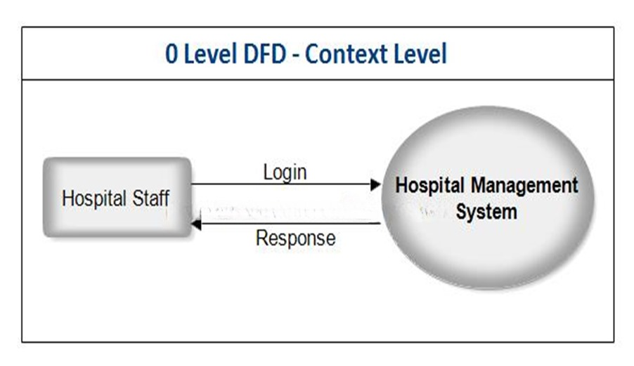

0 LEVEL CONTEXT LEVEL DIAGRAM

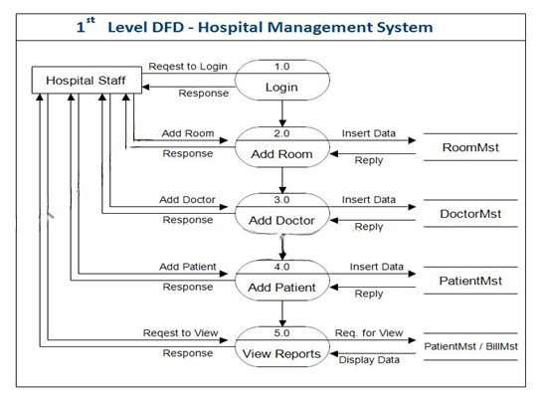

1ST LEVEL CONTEXT LEVEL DIAGRAM

* **USE CASE DIAGRAM**

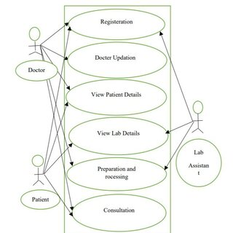

USE CASE DIAGRAM OR UML DIAGRAM FOR HOSPITAL MANAGEMENT SYSTEM

**CHAPTER – 3**

**(SPECIFIC REQUIREMENTS)**

* **PERFORMANCE REQUIREMENTS**
* **Response time**- The system will give responses within 1 second after checking the patient information and other information.
* **Capacity**-The system must support 1000 people at a time
* **User interface**- User interface screen will response within 5 seconds
* **SECURITY REQUIREMENTS**
* Want take the responsibility of failures due to hardware malfunctioning.
* Warranty period of maintaining the software would be one year.
* Additional payments will be analyzed and charged for further maintenance.
* If any error occur due to a user’s improper use. Warranty will not be allocated to it. 5. No money back returns for the software.
* **SOFTWARE SYSTEM ATTRIBUTES**
* **Usability**: Software can be used again and again without distortion.
* **Availability**: The system shall be available all the time.
* **Correctness**: Bug free software which fulfills the correct need/requirements of the client.
* **Maintainability**: The ability to maintain, modify information and update fix problems of the system.
* **Accessibility**: Administrator and many other users can access the system but the access level is controlled for each user according to their work scope .
* **FUNCTIONAL REQUIREMENTS**
* **LOGIN :**
* **PATIENT**: Can login using unique Id and Password .
* **DOCTOR**: Can login using unique Id and Password and can view his/her profile.
* **DOCTOR MODULE**
* Can add a new doctor by filling all the details after this system shall show a confirmation message. Can Remove a doctor by just one click after this system shall show confirmation message.
* **PATIENT MODULE**
* Can also update details after this system shall ask for re-enter password and after verifying password shall update details.

# 

**CHAPTER – 4**

**(DESIGN)**

* **ER DIAGRAM**

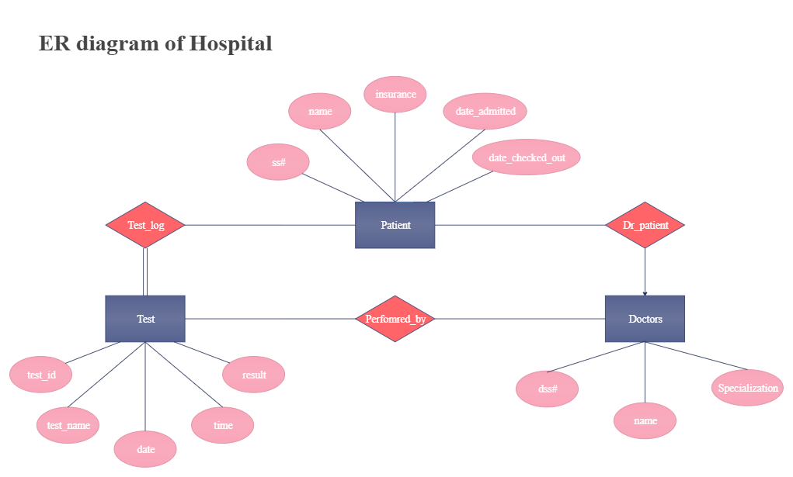

* **DATA DESIGN**

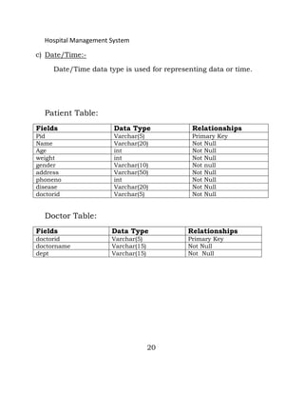

* **REFERENCES**
* https://www.officetimeline.com/make-gantt-chart/excel
* <https://medium.com/@datamateuaecrescent/hospital-management-systemfeatures-objectives-62eeb13f4fc4>
* R.S Pressman, Software Engineering: A Practitioner’s Approach, Mc-Graw-Hill, Edition-7 (2010).
* P. Jalote , an Integrated Approach to Software Engineering, Narosa publication house, Edition -3 (2011)

**CHAPTER – 5**

**(FEASIBILITY STUDY)**

* **TECHNICAL FEASIBILITY**

A study of resource availability that may affect the ability to achieve an acceptable system.

This evaluation determines whether the technology needed for the proposed system is avail-

-able or not.

* Can the work for the project be done with current equipment existing software technol-

-ogy & available personal?

* Can the system be upgraded if developed?
* If new technology is needed then what can be developed?

This is concerned with specifying equipment and software that will successfully satisfy the user

requirement. The technical needs of the system may include:

**FRONT END AND BACK END SELECTION**

An important issue for the development of a project is the selection of suitable front-end and back

-end. When we decided to develop the project we went through an extensive study to determine the

most suitable platform that suits the needs of the organization as well as helps in development of the

project. The aspects of our study included the following factors.

* **FRONT – END SELECTION** 
  + It must have a graphical user interface that assists employees that are not from IT background
  + Scalability and extensibility
  + Flexibility
  + Robustness
  + According to the organization requirement and the culture
  + Must provide excellent reporting features with good printing support
  + Platform independent
  + Easy to debug and maintain
  + Event driven programming facility
  + Front end must support some popular back end like Ms Access
* **BACK – END SELECTION**
* Multiple user support
* Efficient data handling
* Provide inherent features for security
* Efficient data retrieval and maintenance
* Stored procedures
* Popularity
* Operating System compatible
* Easy to install
* Various drivers must be available
* Easy to implant with the Front-end
* **OPERATIONAL FEASIBILITY**

It is mainly related to human organizations and political aspects. The points to be considered are:

* What changes will be brought with the system?
* What organization structures are disturbed?
* What new skills will be required? Do the existing staff members have these skills? If not, can they

be trained in due course of time?

The system is operationally feasible as it very easy for the End users to operate it. Itonly needs basic

information about Windows platform.

* **ECONOMICAL FEASIBILITY**

Economic justification is generally the “Bottom Line” consideration for most systems. Economic

Justification includes a broad range of concerns that includes cost benefit analysis. In this we weigh

the cost and the benefits associated with the candidate system and if it suits the basic purpose

of the organization i.e. profit making, the project is making to the analysis and design phase.

The financial and the economic questions during the preliminary investigation are verified to estimate

the following:

* The cost to conduct a full system investigation.
* The cost of hardware and software for the class of application being considered.
* The benefits in the form of reduced cost.
* The proposed system will give the minute information, as a result the performance is improved which

in turn may be expected to provide increased profits.

* This feasibility checks whether the system can be developed with the available funds.
* The **Hospital Management System** does not require enormous amount of money to be developed.
* This can be done economically if planned judicially, so itis economically feasible.
* The cost of project depends upon the number of man-hours required
* **SCHEDULE FEASIBILITY**

Time evaluation is the most important consideration in the development of project. The time

schedule required for the developed of this project is very important since more development

time effect machine time, cost and cause delay in the development of other systems .

A reliable **Hospital Management System** can be developed in the considerable amount of time.